Code compilation in Linux box

Configurations:
I.Putty:
Need access to the below server to access and build the code in Linux box.
VLLTCNPCIDEV1.fisdev.local
Once you got the access , please configure this server in putty and save it.
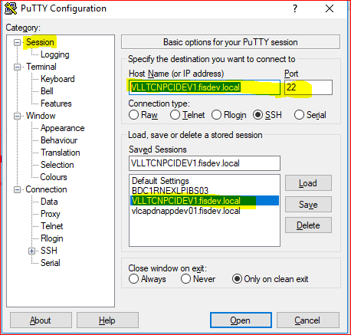

2.WINSCP
Configure the same in WINSCP to move/view the code changes and save the session using your domain EID and password.
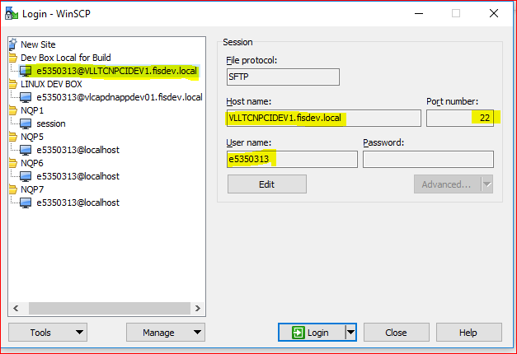
Code Build/Changes:
Once configurations are done, please login to the server using domain Eid and password in putty.
Step1: Go to the code/build location (/dnserver/devel) and you can see list of software and data center MU folders.
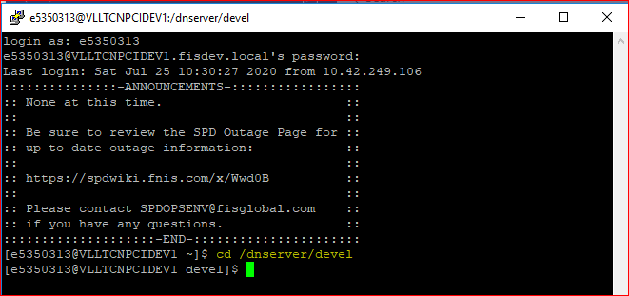

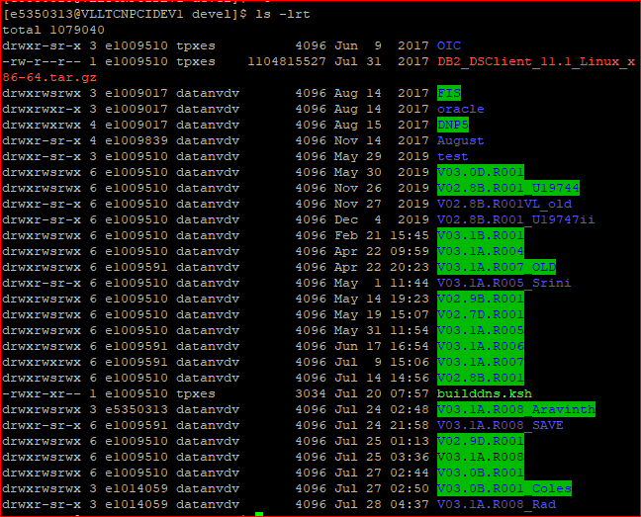
Step2:Create a new build folder
If you want to make/include any changes on top of the current build for your testing purpose, then make a copy of the original MU folder to your new build folder.
For Example, I have copied the August MU level code to new folder called V03.1A.R008_Aravinth.
Copy command:
Create a mu folder(V03.1A.R008) within your build folder (V03.1A.R008_Aravinth) and copy the files from original MU folder to your folder.
cp -r --preserve V03.1A.R008 V03.1A.R008_Aravinth\V03.1A.R008\
Here, Preserve will present the previous build details and it will allow to build only the new change modules instead of making complete build.
V03.1A.R008 – Source folder
V03.1A.R008_Aravinth – Destination folder.
Also, copy the builddns.ksh file from /dnserver/devel to your folder V03.1A.R008_Aravinth\V03.1A.R008)
Note: The original build folder should present within your new build folder like below.
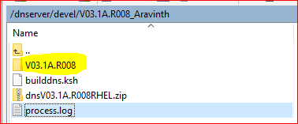
Step3: Move changes to Linux Box.
Once the build environment / folder got created move your changes through WINSCP from your local to Linux box.
Eg.
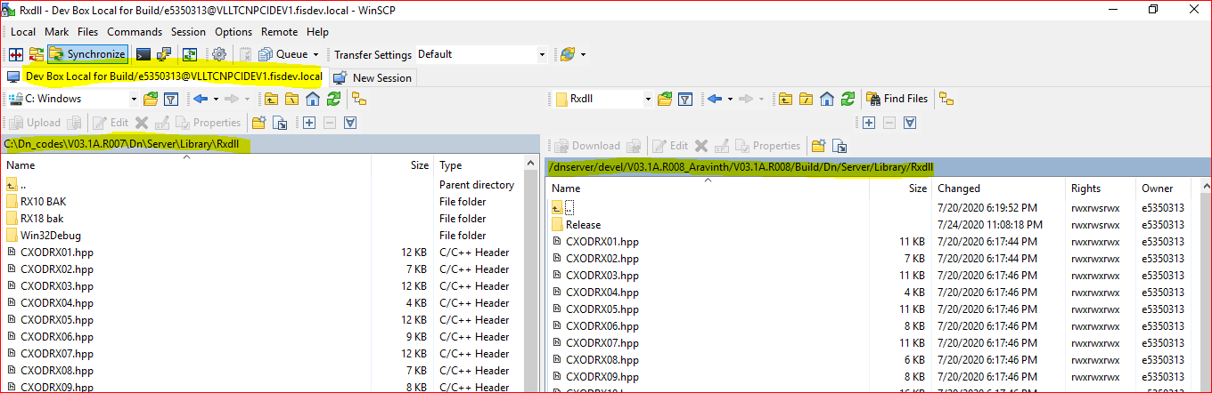
Step4: Build changes
After moved the changes to Linux box, Start build the code by using the below command.
Command: builddns.ksh V03.1A.R008 Noget Build Release
Once build completed , please see the processlog.txt file to see error details which you got during the build.
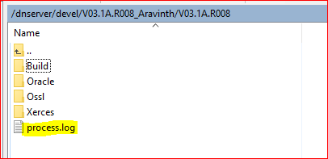
Once the build is completed new archive file would be created in the bin folder.
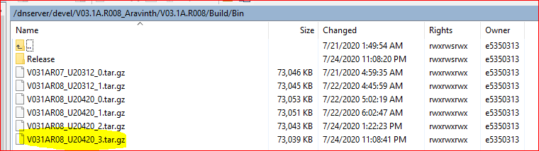
Step5 : Copy the tar file to Linux Dev box.
Copy the tar file to Linux Dev BOX or the testing location where you want and extract the changes in bin folder.
Dev box:
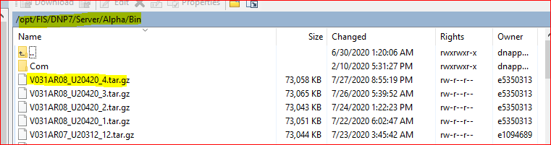
Extract the changes in bin folder using the below command .
Command:
tar -zxvf V031AR08_U20420_4.tar.gz
Once the changes are extracted bounce the server/switch.
Stop command:
stopDN.ksh FM / stopDN FM
Start Command:
startDN.ksh FM or startDN FM

